CS 2302 – Project 4, Option B  
Professor Diego Aguirre  
Victor Huicochea – 80643271

**Project 4 – Trees**

**Introduction**

The purpose of this project is to practice the use of Hash Tables. The hash table must use chaining to solve collisions. The program should have a method to determine the average number of comparisons required to perform a successful retrieve operation and another method to compute the table’s load factor.

**Proposed Solution**

Two different files were written to solve this project. One of them contains the classes for the Hash Table and the Node, and the other one is the Main program, where all operations are done.

The Main program contains several functions. One of them creates the hash table from a given file. Two other functions are used to get and count the anagrams for a given word. Another two functions calculate the average number of comparisons required to perform a successful retrieve operation. Lastly, a function gets the load factor for a hash table.

Running Time Graph

**Experimental Results**

1.- Testing with the words.txt file.

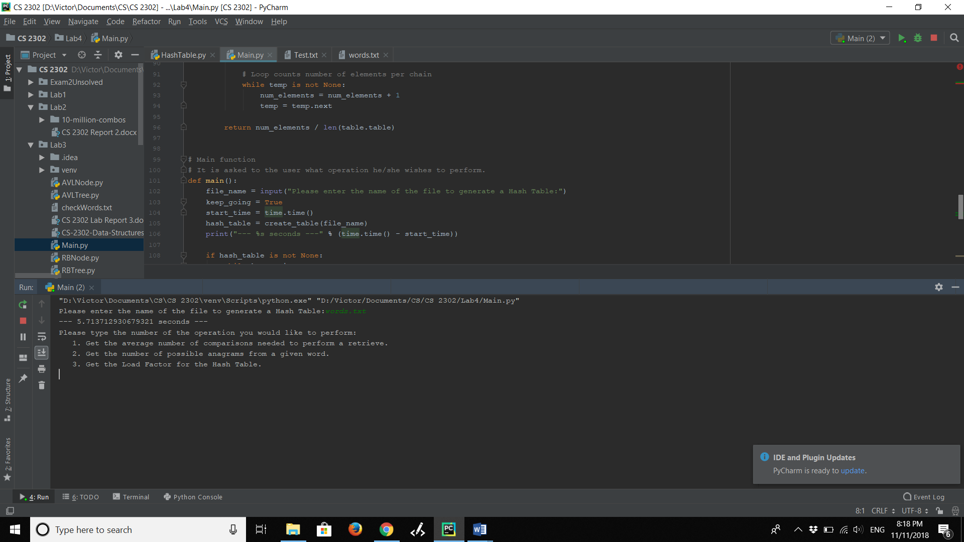

2.- Testing with an empty file.

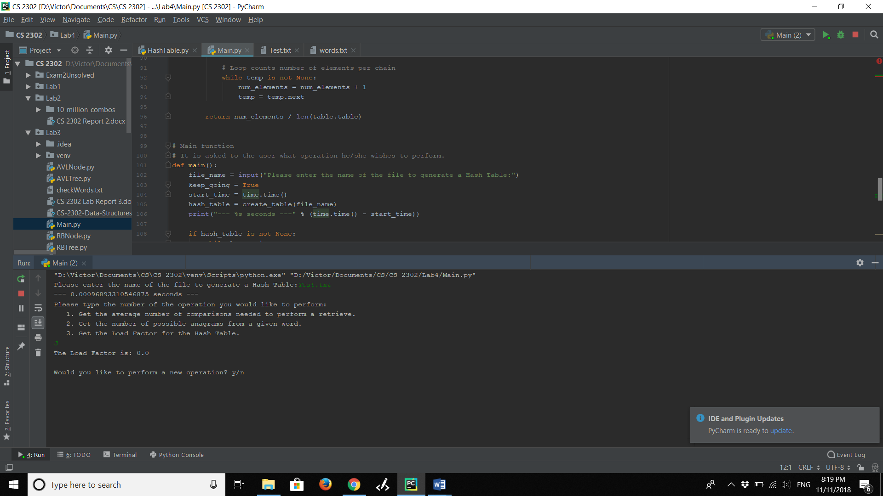

3.- Testing with a non-existing file.

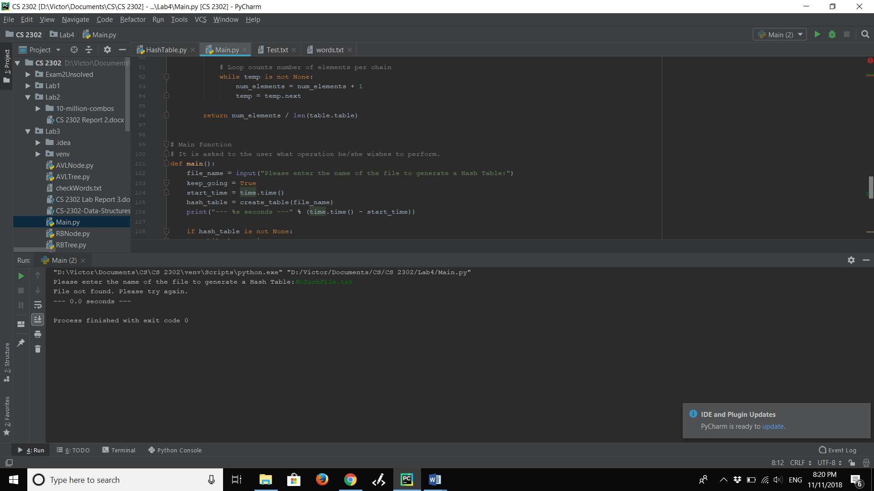

**Conclusions**

This project helped me to understand the use of Hash Tables. Now I feel more comfortable working with hash tables since I am now more capable of visualizing how data moves after every function.

I also realized it is hard yet important to come up with a good hashing function because that is what makes hash tables successful.

**Appendix – Source Code**

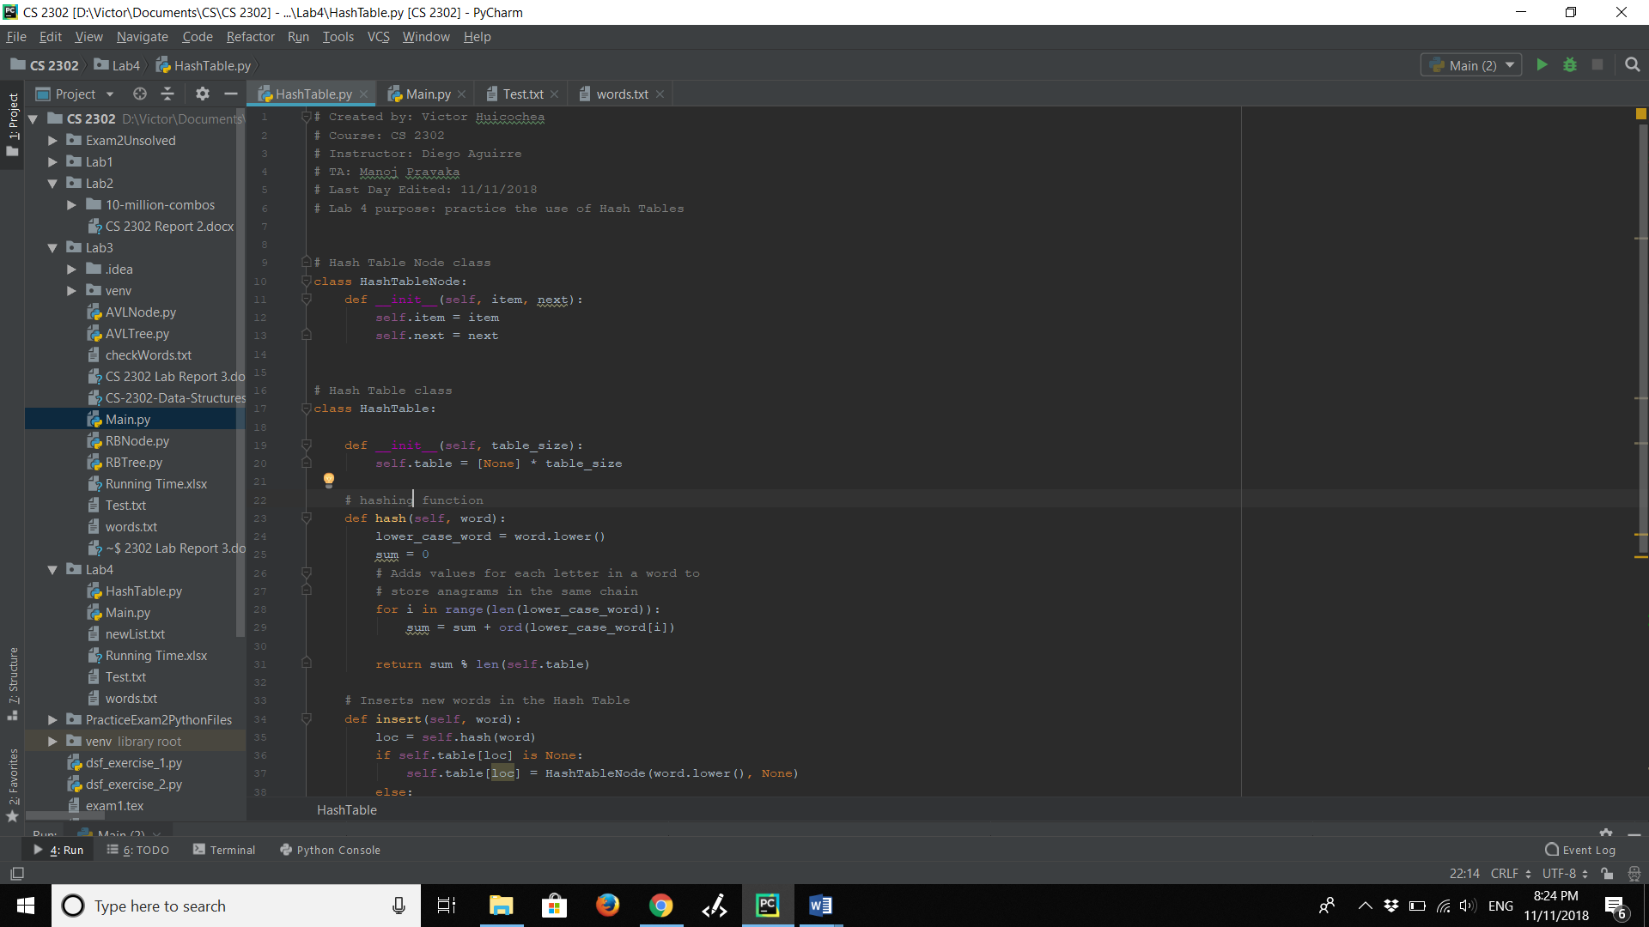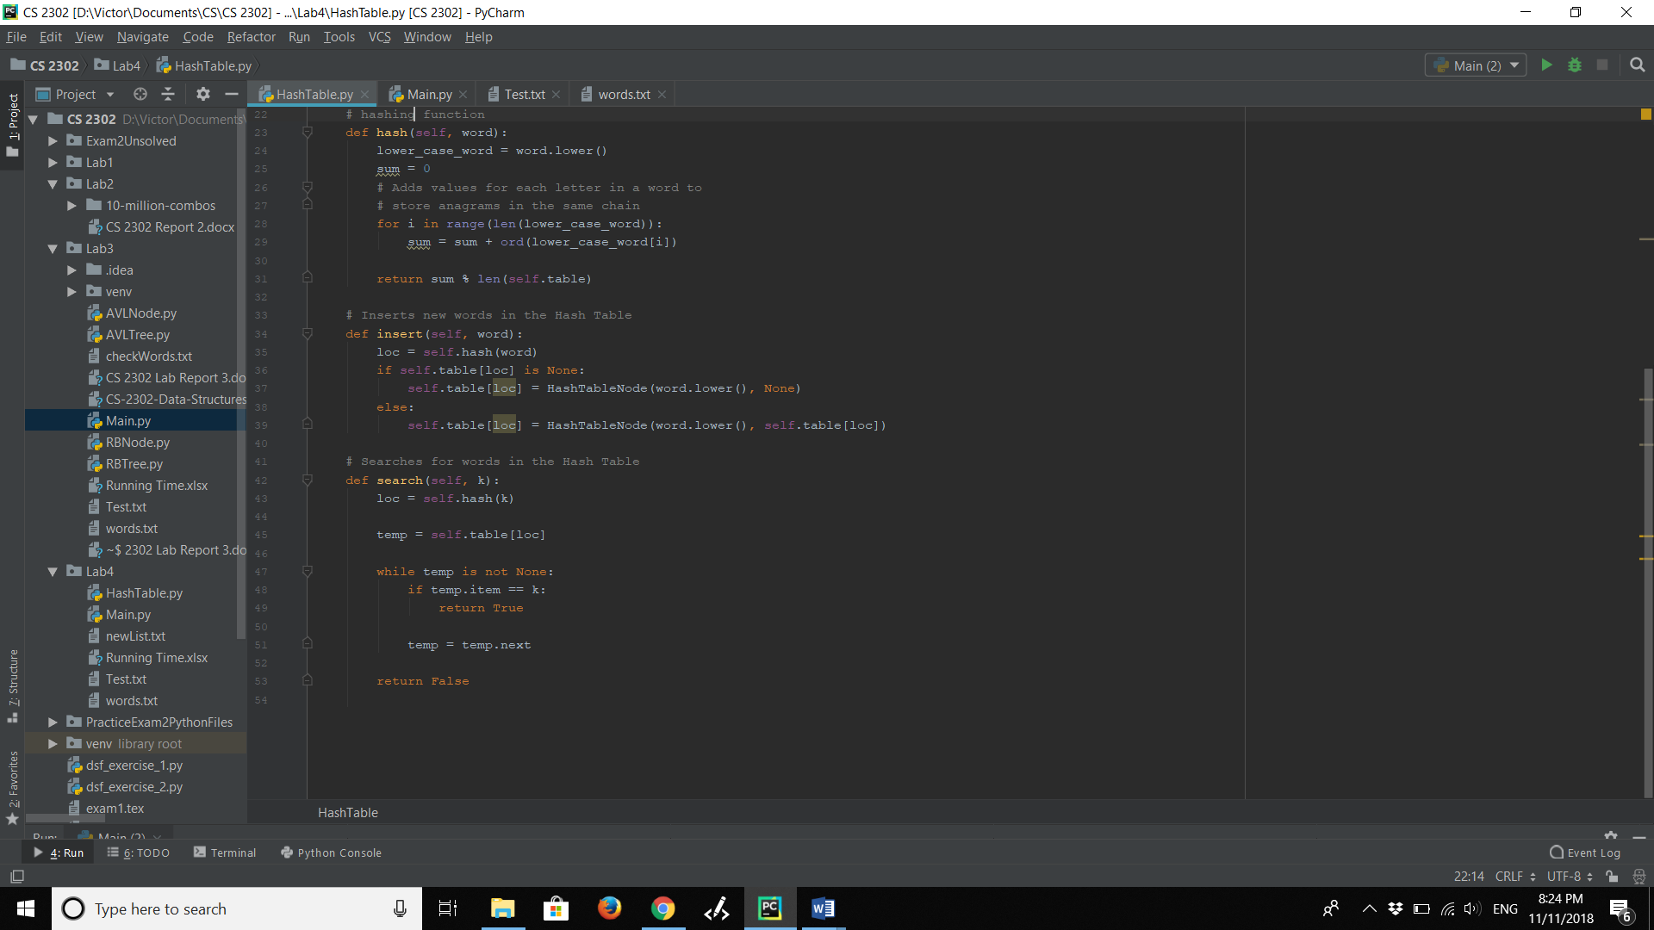

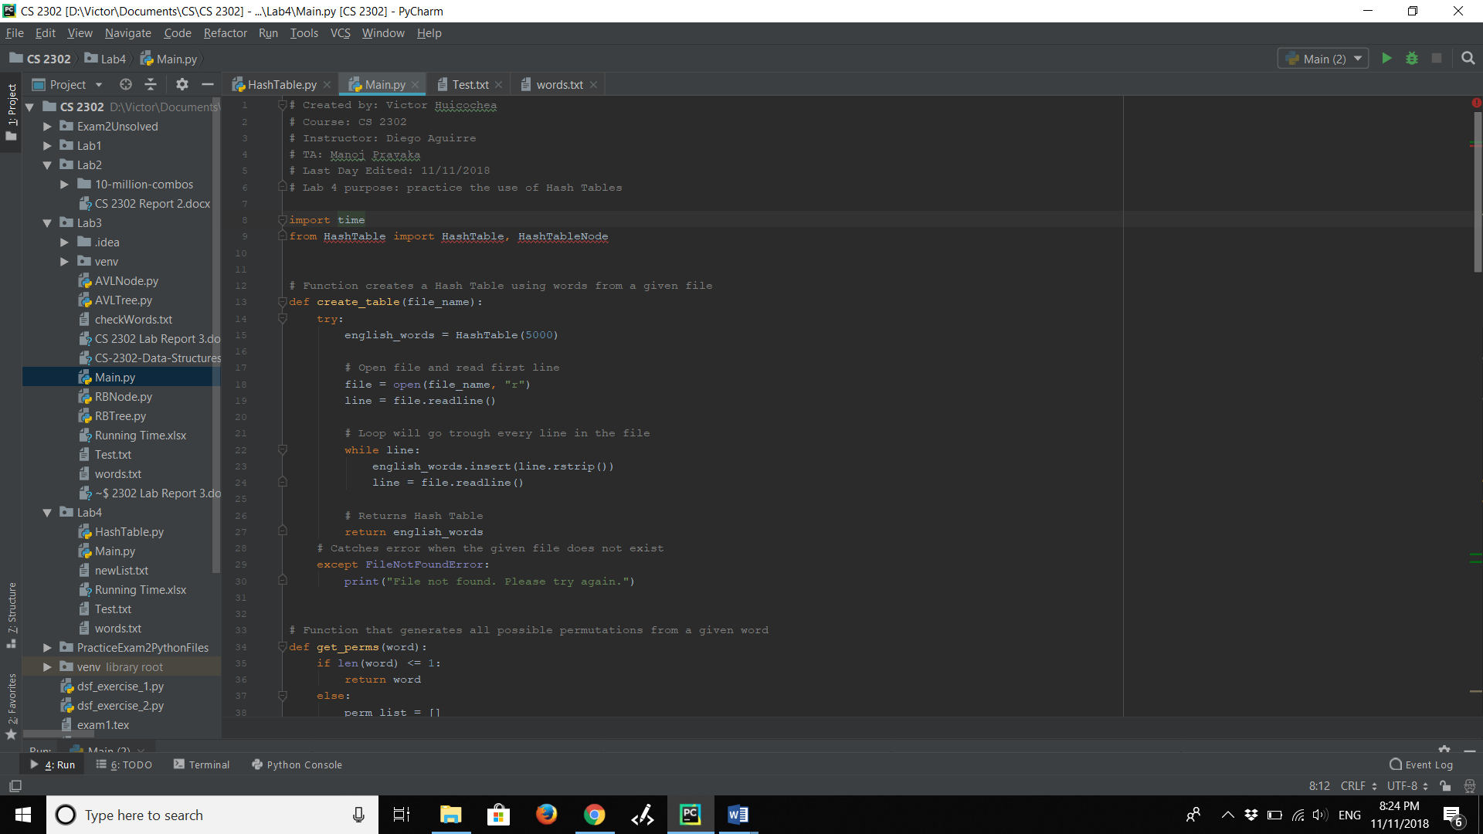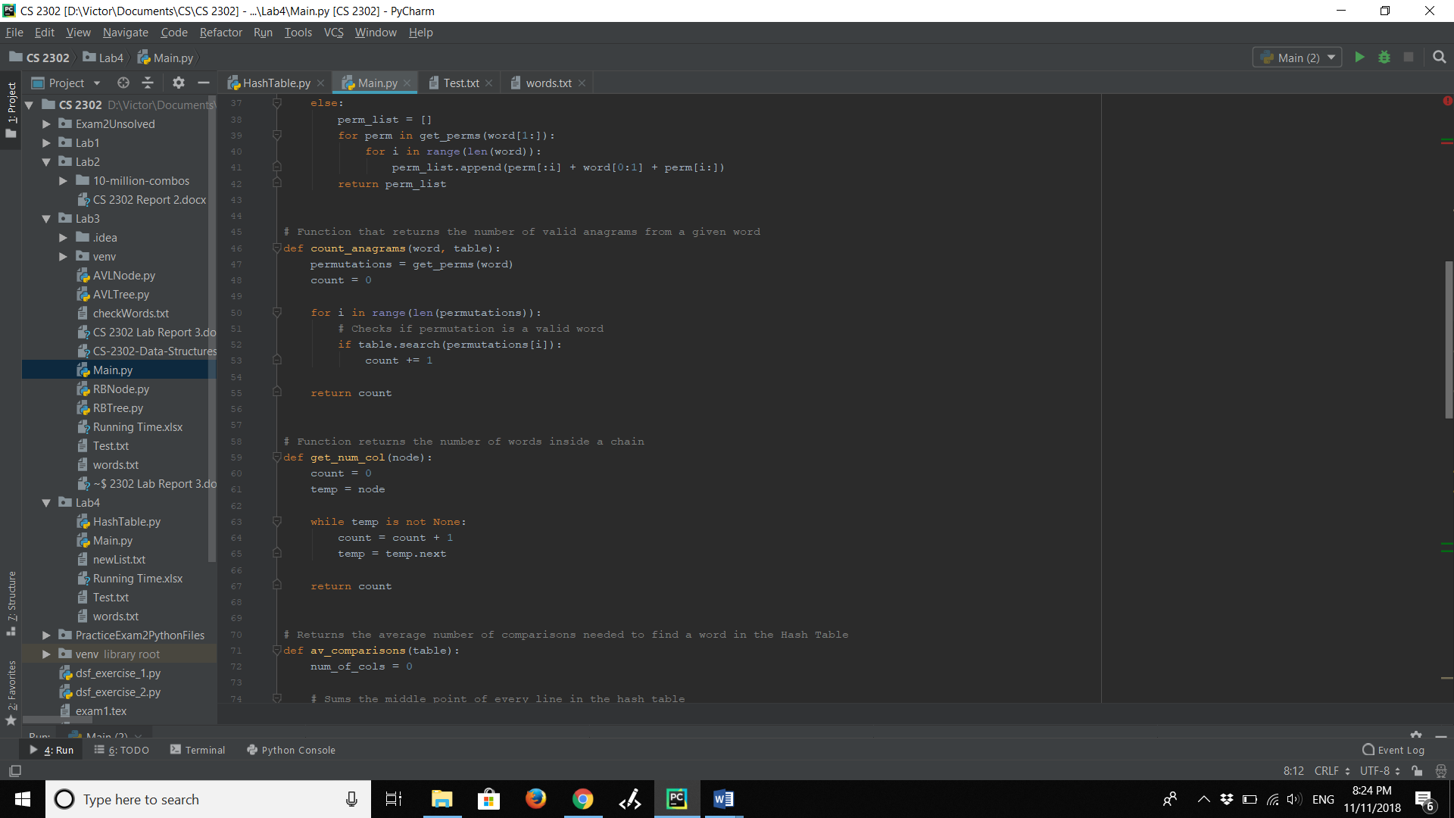

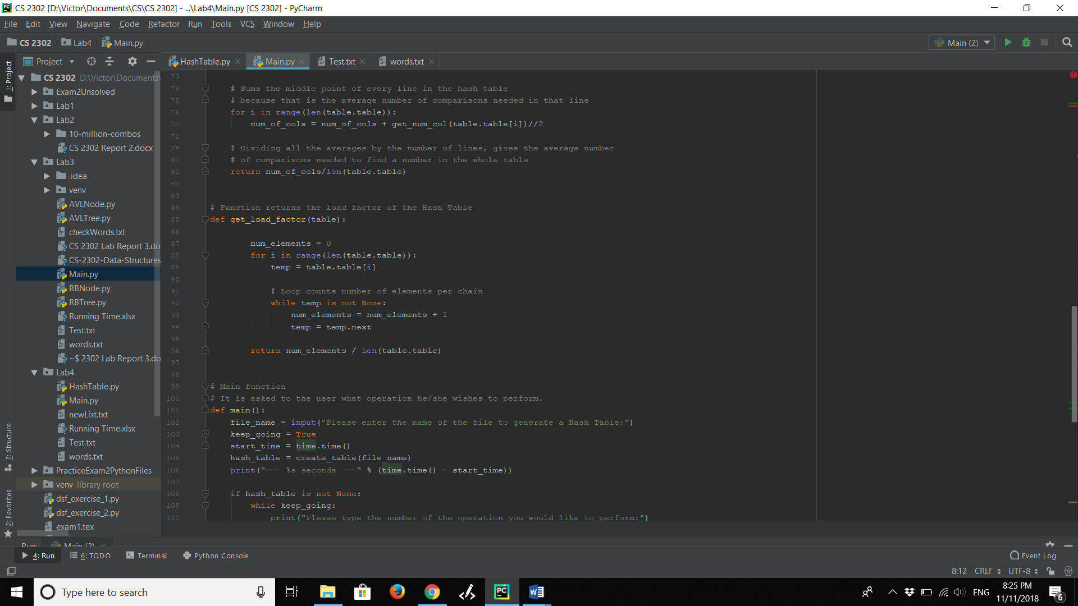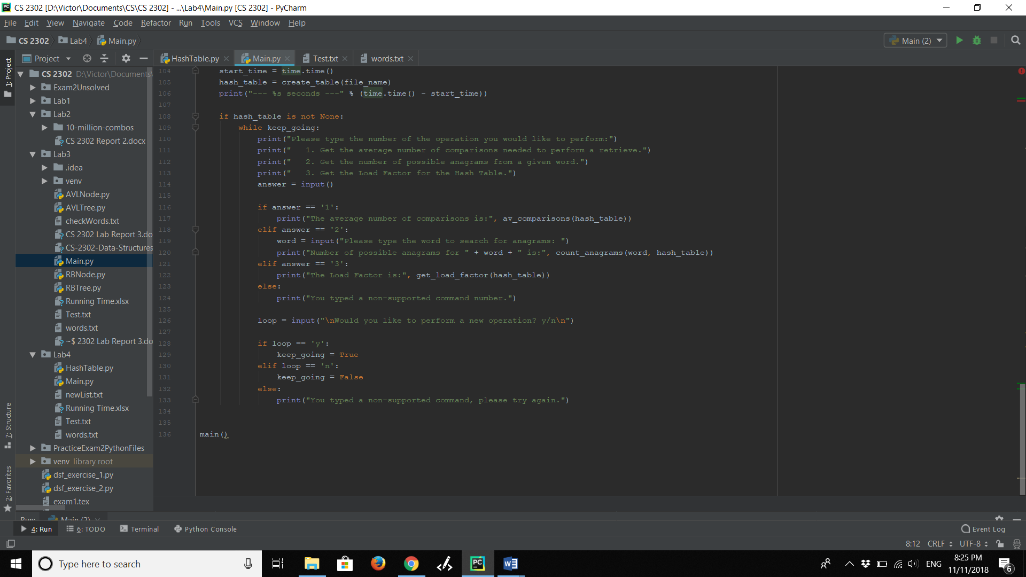

**Academic Honesty Certification**

****I certify that this project is entirely my own work. I wrote, debugged, and tested the code being presented, performed the experiments, and wrote the report. I also certify that I did not share my code or report or provided inappropriate assistance to any student in the class.